
Hi Runner

Welcome to the Lion’s Bridge Trail Running Event, Sunday 24th July 2022.

There are three race distances a HALF Marathon, FULL Marathon and 50k ULTRA.

Start time for all races are 9:30am.

Race Day & Safety Information for Runners

The information below is regarding the race day and addresses points raised from the risk assessment of the course. We ask that all runners take the time to read this so hopefully it will make the experience of the event more pleasurable and safer for yourself and others.

Registration
Registration will open at 8:30am at the Gin Pit Miners Welfare Club, Ley Road, Gin Pit Village, Tyldesley, Manchester, M29 7DW. Runners need to sign in to collect their race number. We ask that runners fill in the reverse of their race number with an emergency contact and telephone number.

Parking
There is a car park at the Welfare Club but we expect it to get very busy. We are trying to get access to a second car park at the rear of the club but this isn’t confirmed yet.

When parking please be mindful not to block in anyone. Do not park on the yellow square on the main car park or you will block the way to the second car park.

Should the car park fill up then please do not park on Ley Road on the approach to the Welfare Club as this road is narrow and it restricts access for the local residents. If the car park is full, please can you park on the side roads of the housing estates off Princess Ave and walk up Ley Road to the Welfare Club.

Facilities at the Welfare Club House
Toilets are available inside the club house. There are no managed facilities for leaving baggage but some runners in the past have left them in the Welfare club’s function room at their own risk. We recommend you leave your belongings in your car as the main car park is next to the race start and finish. There are no changing rooms available.

Refreshments
Cold drinks and snacks are available from behind the bar and hot drinks are available from a drinks machine.

I’m afraid we are not selling pasties at this event unlike during the Gin Pit Double, this is because we don’t seem to get enough interest from runners during this warmer time of the year.

The Course
The HALF marathon is 3 identical laps using the trails around the Gin Pit and Lilford Park.

The FULL marathon is 6 identical Laps of the same course.

The 50k ULTRA is 7 identical Laps of the same course, plus a small extra 8th loop.

The main lap is marked with yellow and black signs.
The small 50k lap has orange and black signs which say 50km.

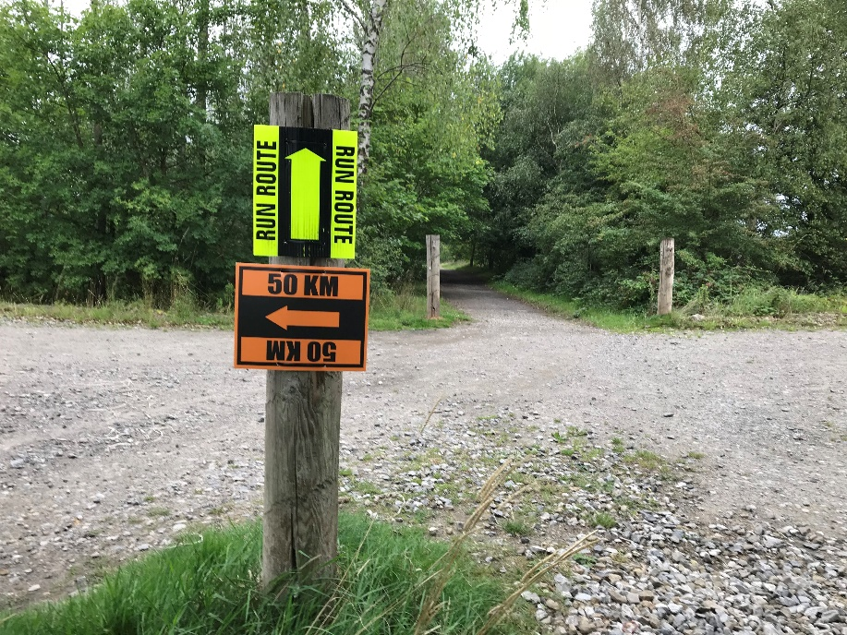

All races start together at 9:30am from the side of the Gin Pit Miners Welfare Club where registration takes place.

Transferring Between Races
If you have entered the full marathon but change your mind and only want to run the half. This is fine, all you need to do is, once completing the 3rd lap tell the time keeper and you will be transferred onto the halves results. Don’t worry you will still get a medal. Likewise, if you are only down for running the half, but on the day are feeling particularly strong then you are welcome to continue for another 3 laps and again you will be transferred to the full marathon results and still get a medal. The same goes for the 50k.

Basically, we don’t mind you changing what race distance you complete on the day. All we ask is that you make it clear to the time keeper when you finish so we can record your time correctly for the correct distance.

Course Information
There are NO marshals out on the course. Direction signs will be put up at all turns and junctions. Yellow arrows will be sprayed on the trail sections (weather permitting). Competitors will be reminded what to look out for at the pre-race briefing.
On the bottom of the race numbers there will be a mobile contact number for runners to use should they get lost.

None of the route is closed to the public.
On the trails you can expect to come across, walkers, dog walkers, cyclists, horse riders and farm vehicles.
On the road sections these will include pedestrians and traffic.
We ask for you to be courteous to all other users of the course as they have the same right to be there as you.

Public roads will be open to traffic, runners are to stay on the pavements and the normal Highway Code is to be used at all times on these sections of the course. At road junctions runners must use the “Green Cross Code” you have no rights over the traffic. Please take special care when crossing Queensway, as some cars travel very fast along this stretch of road even though it is supposedly a 30 mph speed limit! We want you to all finish safely.

The Guided Busway will be operating. It crosses the course twice, at the 0.5 mile and 2.5 mile points each lap. Please look out for the purple guided buses when crossing. They are very quiet so you need to be vigilant when crossing at these points. There is also a path running alongside to the Guided Busway which is open to the public. It is very popular with pedestrians, dog walkers and cyclists, please also look out for these users when crossing.

Water Station
The plan is for one water station at the start/finish where you will also have your laps counted. You are welcome to leave your own drinks and food at this water station. Please clearly mark them up with your name so other runners know they are yours and not for general consumption. I suppose it goes without saying if it has someone else’s name on it then don’t drink or eat it! Anything you leave at the water station is done so at your own risk.

There will be a second unmanned water station at the far side of the course in the field just before you turn right onto Green Lane.

Timing
Please make sure the Time Keeper at the check point at the Start/Finish ticks off your race number each lap so we know how many laps you have completed and when you have finished. You won’t want to have to run an extra lap because we had missed recording one!

Should you drop out please let a marshal at the finish know. This is very important, so we know you are all safe and accounted for. If we don’t know, then we could end up searching for you needlessly.

First Aid
There will be 2 first aid medics in attendance at the Start/Finish at the Gin Pit Miners Welfare Club.

Should you see a distressed runner out on the course or become injured yourself tell a Marshal or a first aid medic at the start/finish or ring the emergency mobile number on the bottom of your race number so a first aid medic can go out and attend to you or the runner.

Clothing
The use of hydration packs and sun cream are recommended for warm weather conditions.
For cold weather we recommend hats, gloves, long sleeved tops and leggings.
For wet weather we recommend using a waterproof jacket.

The course is mainly made up of trails with a good hard-core surface and is runnable in road trainers. Please expect to get some element of mud on your trainers so we don’t advise runners to bring a brand new pair of shiny road shoes.
If the weather has been particularly wet the trails can get very muddy in a few places with some large puddles. In this case runners may prefer to use trail shoes but old road shoes will still be adequate.

Ipod Use
We don’t want to spoil the enjoyment of the event for the competitors and cannot police IPod use so therefore we do not ban the use of Ipods or similar devices but we do not endorse their use for the following safety reasons:-

Most of the route is on trails which are fairly safe for IPod use but some short sections of the event are held on open public roads and competitors need to beware of all other road users including pedestrians and especially traffic. Should competitors elect to use Ipods or similar devices, we ask you switch them off for these public road sections.

Also, the course is not marshalled, runners need to concentrate on looking out for the arrows and signs which guide them around the course, Ipods can distract runners and this may lead to them straying from the course.

Should runners elect to use Ipods then we would like to recommend the use of bone conductor earphones as these don’t go in your ears and therefore allow runners to still hear other sounds around them.

Competitors use Ipods and similar devices completely at their own risk.

Litter
We ask that you don’t drop your litter. If you are seen dropping litter, you may be disqualified.
Please leave water bottles at the start/finish or visible on the trail shortly afterwards for the Marshals to collect or keep them with you. There are also bins in Lilford Park and along Green Lane. If you have any other litter, for example gels sachets, again please leave them also at the start/finish or again we ask you to use the bins in Lilford Park or on Green Lane
Sadly, there is litter out there on parts of the course dropped by the general public but pleased don’t let us runners be adding to it.

Awards
All finishers will receive a bespoke medal and there will be trophies for first male and female in the full marathon and the 50k ultra.

Results
Results will be available shortly after the event at the following link:-
www.malcsblog.net/results

Facebook
If you are on Facebook and fancy getting involved in a bit of Lions Bridge running banter with fellow runners or simply enjoy reading some, then have a look out for the Gin Pit Marathon Events Group. There are also some good photos of the course and even the occasional bit of useful information.

Lastly, we wish you good luck and hope you enjoy the Lions Bridge Trail Running Event.

