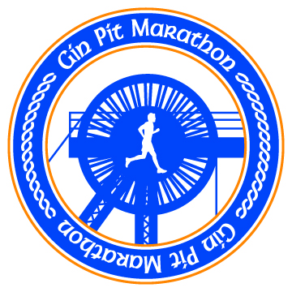

Suggested local places to stay for the Gin Pit Marathon

The Greyhound Hotel
Warrington Road
Leigh, WN7 3XQ
Tel 01942 671256
http://www.sportinglodgeinns.co.uk/leigh/experience/

Holiday Inn Express
Sale Way
Leigh Sports Village
Leigh, WN7 4JY
Tel 01942 366 334
http://www.hiexpressleigh.co.uk/

Premier Inn

Yew Tree Way

Golborne

WA3 3JD

Tel 0871 527 8500

http://www.premierinn.com/en/hotel/HAYSTO/haydock

Holiday Inn

Lodge Lane

Newton-le-Willows

Haydock

WA12 0JG

Tel 0871 423 4876

http://www.ihg.com/holidayinn/hotels/gb/en/haydock/wrtha/hoteldetail

Novotel - Manchester West
Worsley Brow, Worsley
Manchester, M28 2YA
Tel 0161 799 3535
http://www.novotel.com/gb/hotel-0907-novotel-manchester-west/index.shtml

Marriott Hotel
Worsley Park
Walkden Road
Manchester
M28 2QT
Tel 0161 975 2000
http://www.marriott.co.uk/hotels/travel/mangs-worsley-park-a-marriott-hotel-and-country-club/

